

Numerical Analysis

Lab 1



Task 1:

>> matriz = [1 2 3 4 5;6 7 8 9 10;11 12 13 14 15;16 17 18 19 20;21 22 23 24 25]

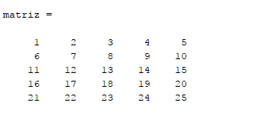

1. >> matriz’

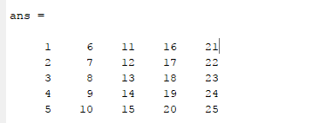

1. >> matriz/2

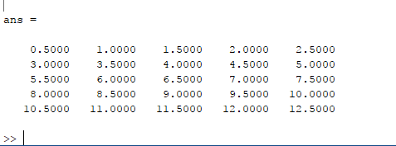

1. >> d=det(matriz)

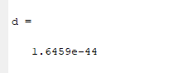

1. >> inv(matriz)

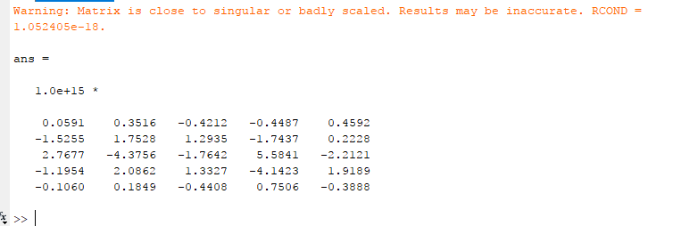

1. >> matriz(:,2)

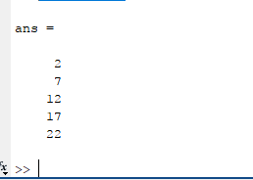

1. >> matriz(4,:)

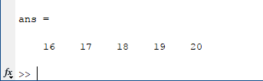

Task 2:

>> z = [0.9347,0.3835,0.5194,0.8310]

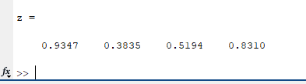

1. >> max(z)

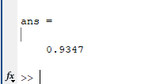

1. >> min(z)

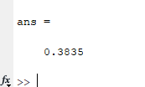

1. >> sort(z)

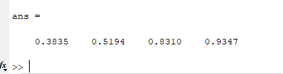

1. >> sum(z)

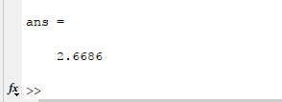

1. >> mean(z)

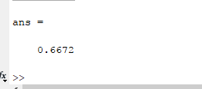

Task 3:

>> eye(4,4)

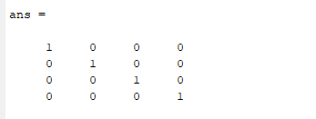

**>> zeros(2,3)**

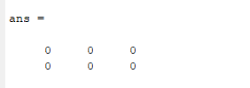

**>> ones(2)**

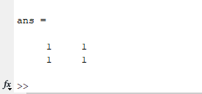

**>> A = [9,7,0;0,8,6;7,1,-6]**

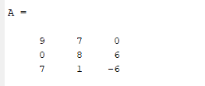

**>> size(A)**

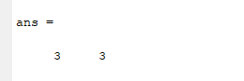

**>> det(A)**

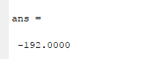

**>> inv(A)**

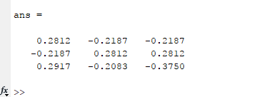

**» x=-pi:0.01:pi;**

**» y=cos(x);**

**» plot(x,y)**

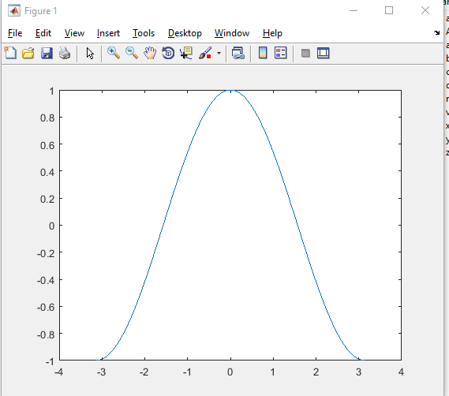

**>> xlabel('x')**

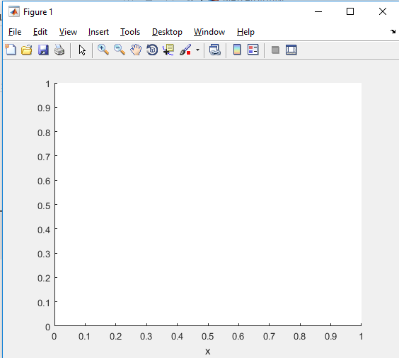

**>> ylabel('y=cos(x)')**

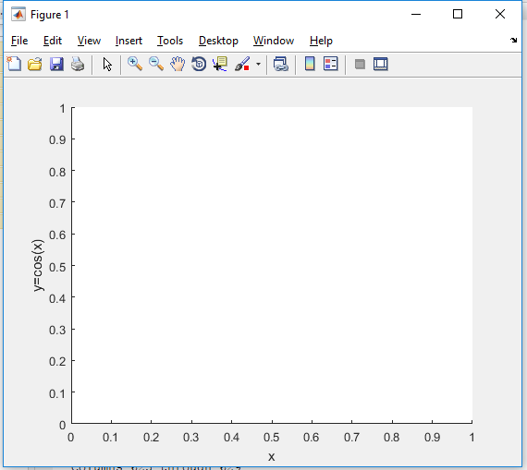

**>> title('Graph of cosine from -pi to pi')**

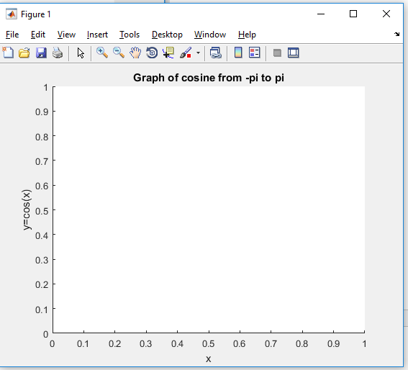

Task 4:

**B = [2 2 3; 4 0 6; 8 1 5]**

**C = [1 1 2; 6 3 5; 1 9 1]**

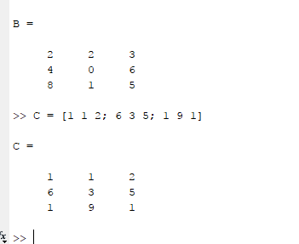

1. >> D = B – C

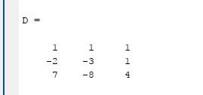

1. >> E = B + C

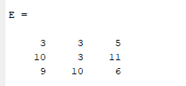

1. >> F= E+2

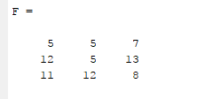

1. >> G=B*C

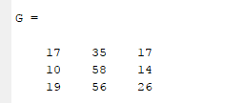

1. >> H=B.*C

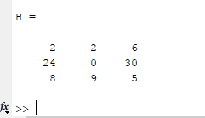

Task 5:

>> f= [1 -12 40.59 -17.015 -71.95 35.88]

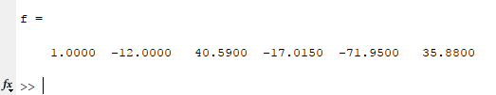

>> polyval(f,9)

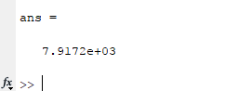

>> x = -1.5:.2:6.7;

>> y=polyval(f,x);

>> plot(x,y)

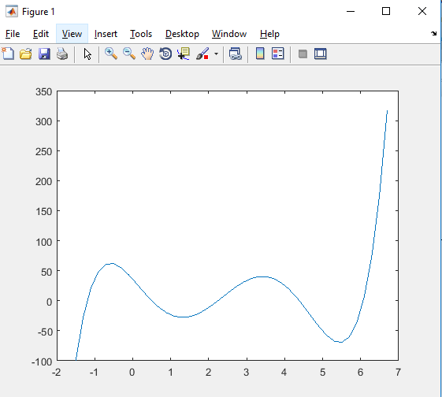

>> roots(f)

